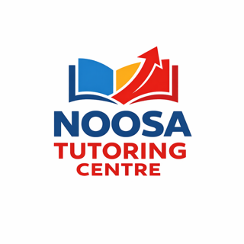

Dear Parents,

Welcome to Noosa Tutoring Centre.

Please read the following and sign below to note you understanding of the terms of beginning tutoring with us.

Once your child has started at the centre they will have been given a time, day and tutor and they are automatically booked in each week until the term ends.

We have engaged the tutor to attend the centre at the time of your child’s session on a weekly basis.

Fees are charged per term. Missed session are not deducted from the term fees.

A “start-up fee” of $15 will be charged to cover all stationery, equipment and administration needed for the entire time each student attends the centre.

It is your responsibility to cancel sessions through TutorBird if your child will not be attending for any reason. This is not done by Admin or tutors.

Sessions not attended, with notice given, are not deducted from term fees – make up sessions are given, with a maximum of three per term.

Make up sessions are not rolled over into the next term.

Late fees do apply for any overdue accounts.

We work on the Department of Education school term dates.
We require one week’s notice to terminate your child’s tutoring at anytime.

Sincerely,
Justine Kerz
Noosa Tutoring Centre
5474 9333

